Answer 6
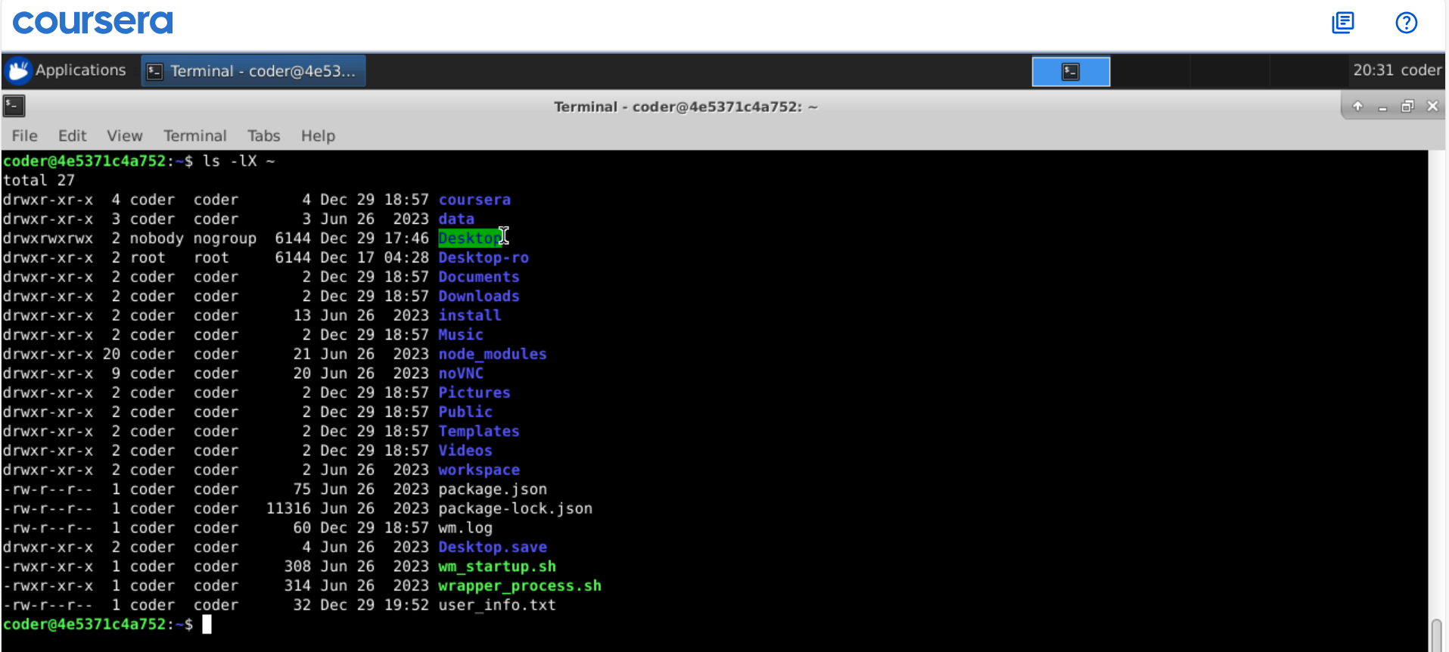
Explanation: Using command ls with option -l and -X give us all the files and dircetories in the home directory with sorted alphabetically and long format. In above case I use ~ which represent my home directory, this can be used if we are running this command from a different directory. Although I am already in my home directory.

